ASSIGNMENT NO.7: Subqueries and Nested Queries
Student Name | Aditya Ballal | Roll Number | 20966
Batch | SY. BSc Data Science | Topic | WB(Assignment-7)

Questions:
Q1) Create a MySQL database named CollegeDB and create two tables: Course and StudentResult.
Course Table
Column Name | Data Type | Constraint
CourseID | INT | PRIMARY KEY
CourseName | VARCHAR(50) | NOT NULL
Fees | DECIMAL(10,2) | NOT NULL
StudentResult Table
Column Name | Data Type | Constraint
StudentID | INT | PRIMARY KEY
StudentName | VARCHAR(50) | NOT NULL
CourseID | INT | FOREIGN KEY
City | VARCHAR(30)
Marks | INT

Insert at least 4 records into Course and 10 records into StudentResult.
Query:
CREATE DATABASE CollegeDB;
USE CollegeDB;

CREATE TABLE Course (
CourseID INT PRIMARY KEY,
CourseName VARCHAR(50) NOT NULL,
Fees DECIMAL(10,2) NOT NULL
);

CREATE TABLE StudentResult (
StudentID INT PRIMARY KEY,
StudentName VARCHAR(50) NOT NULL,
CourseID INT,
City VARCHAR(30),
Marks INT,
FOREIGN KEY (CourseID) REFERENCES Course(CourseID)
);

INSERT INTO Course (CourseID, CourseName, Fees) VALUES
(101, 'BSc IT', 45000.00),
(102, 'BCA', 40000.00),
(103, 'BSc CS', 42000.00),
(104, 'Data Science', 55000.00);

INSERT INTO StudentResult (StudentID, StudentName, CourseID, City, Marks) VALUES
(1, 'Rahul Sharma', 101, 'Mumbai', 78),
(2, 'Priya Patil', 102, 'Pune', 85),
(3, 'Aman Verma', 103, 'Nashik', 67),
(4, 'Sneha Joshi', 101, 'Mumbai', 91),
(5, 'Karan Mehta', 102, 'Thane', 74),
(6, 'Neha Shah', 101, 'Pune', 88),
(7, 'Rohan Desai', 103, 'Mumbai', 69),
(8, 'Meera Kulkarni', 102, 'Nashik', 82),
(9, 'Arjun Nair', 101, 'Thane', 59),
(10, 'Divya More', 102, 'Mumbai', 93);

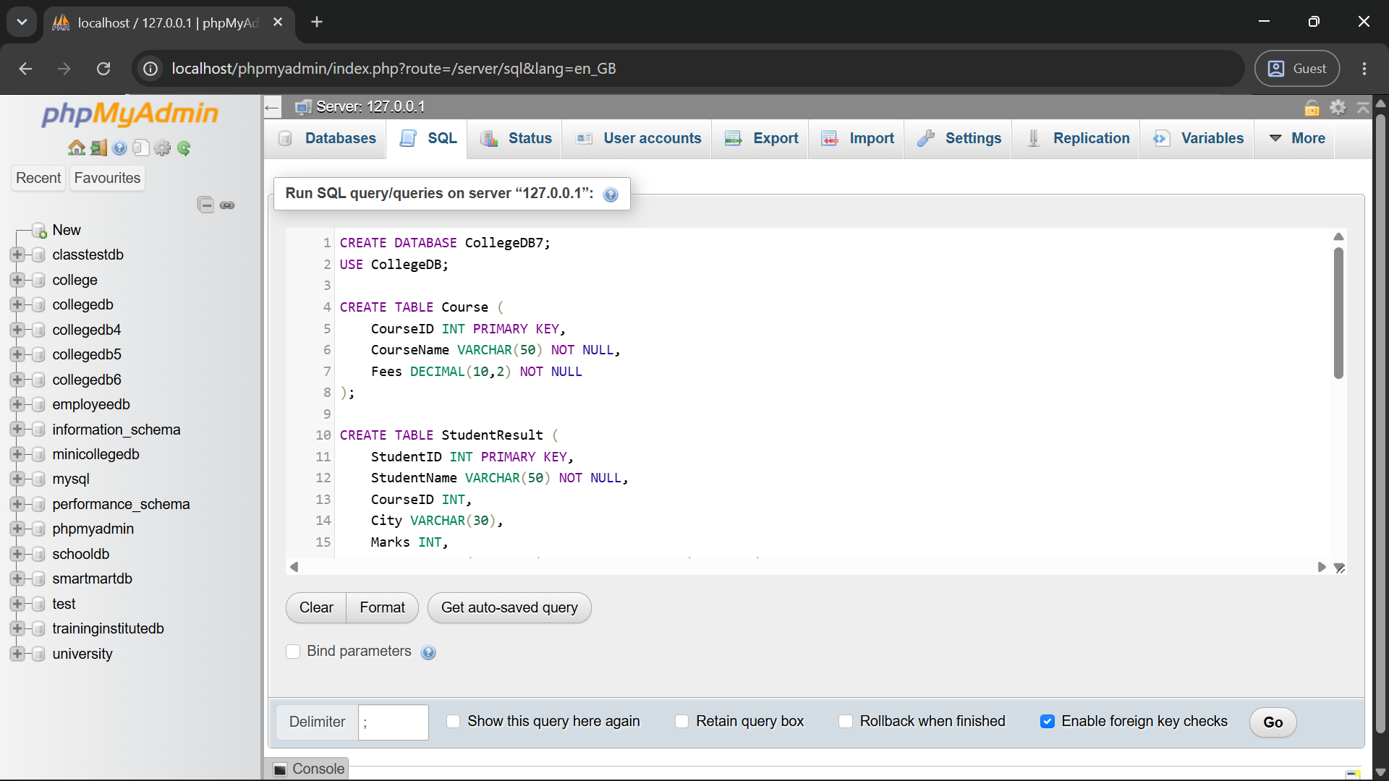
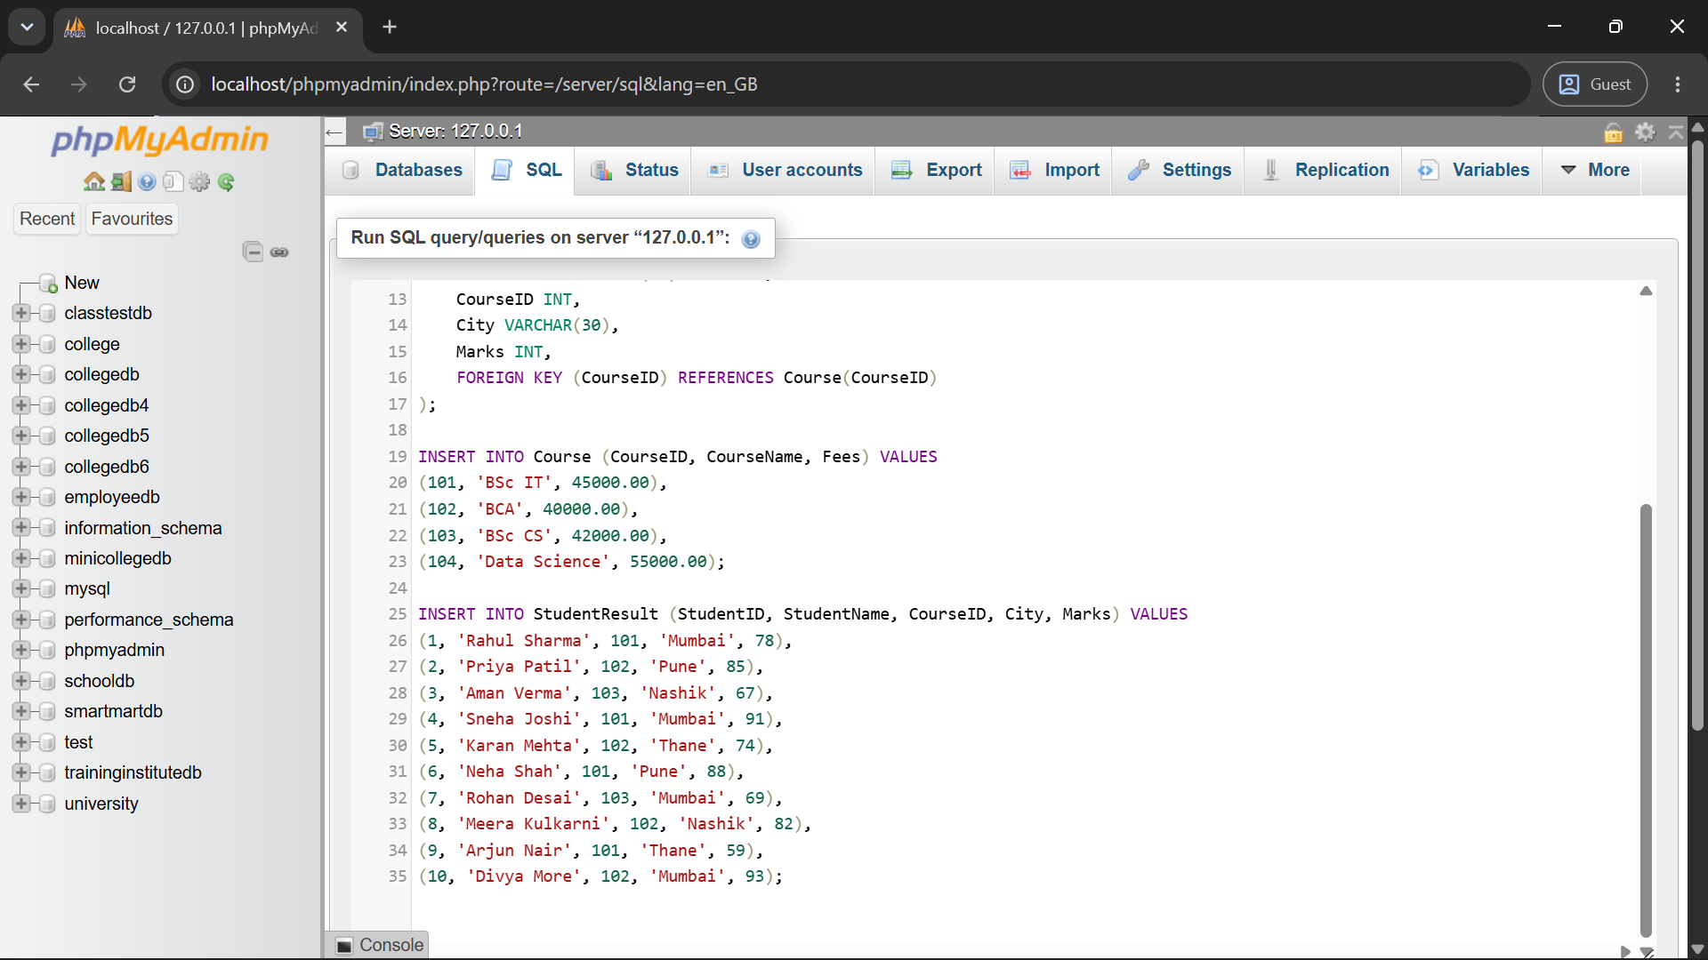

Q2) Write a MySQL query to display students whose marks are greater than the average marks of all students.
The output should contain:
Column
StudentName
Marks
Query:
SELECT StudentName, Marks
FROM StudentResult
WHERE Marks > (SELECT AVG(Marks) FROM StudentResult);
Output:
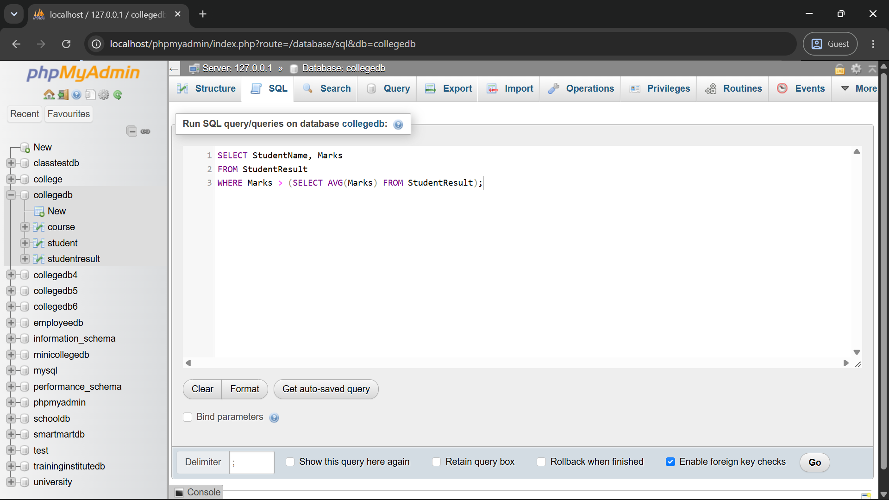
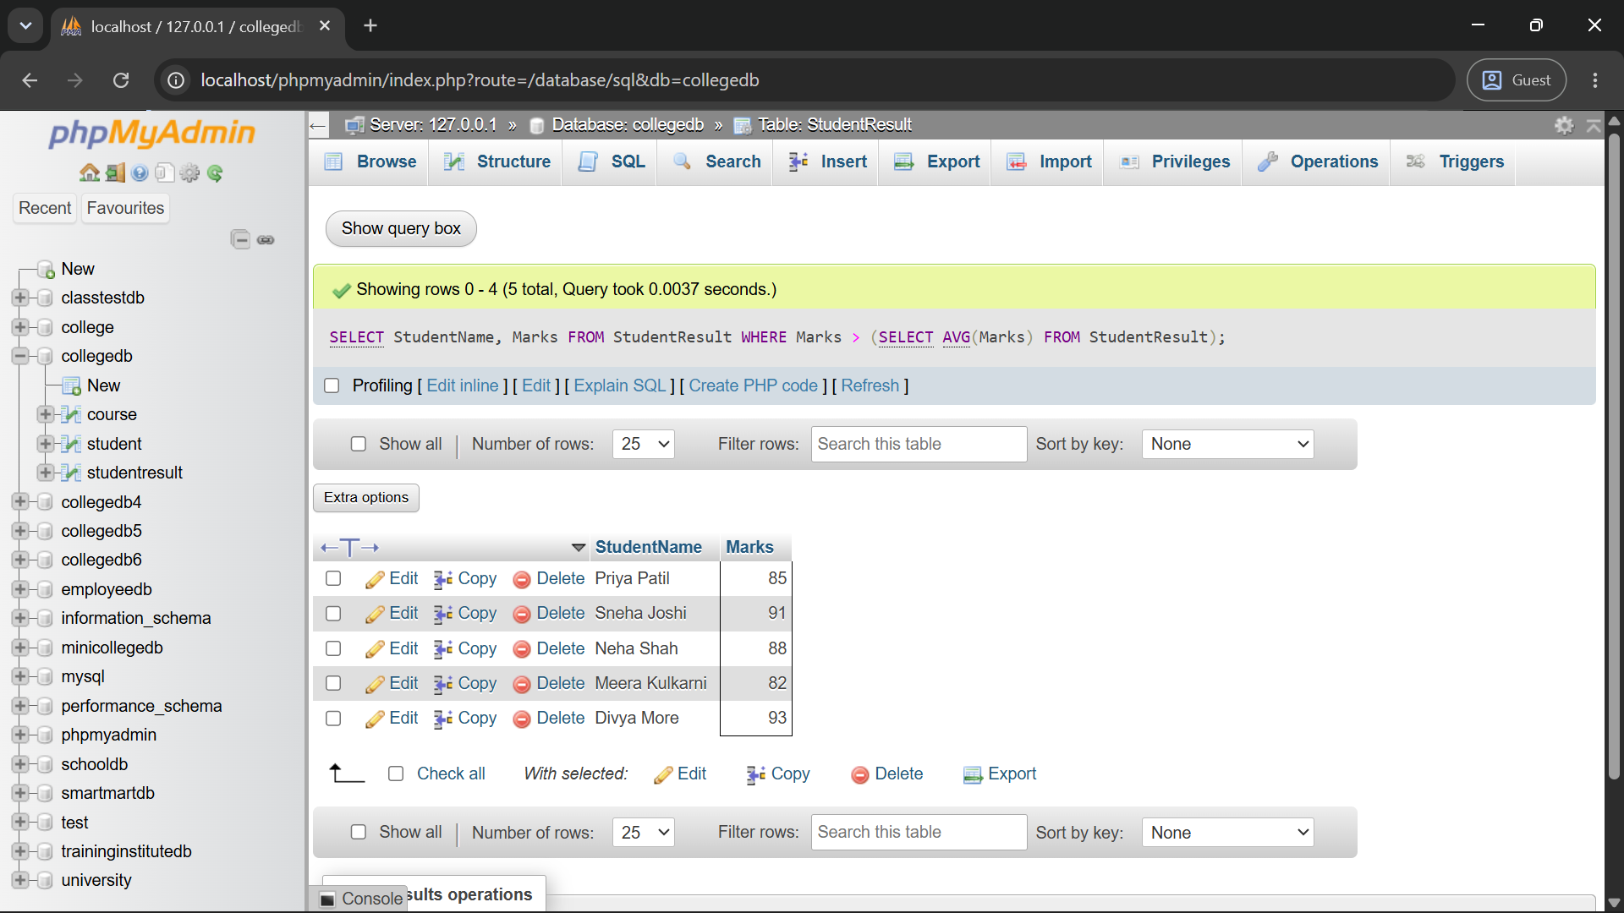

Q3) Write a MySQL query to display all students enrolled in the BCA course using a subquery.
The output should contain:
Column
StudentID
StudentName

Column
CourseID
Marks
Query:
SELECT StudentID, StudentName, CourseID, Marks
FROM StudentResult
WHERE CourseID = (SELECT CourseID FROM Course WHERE CourseName = 'BCA');
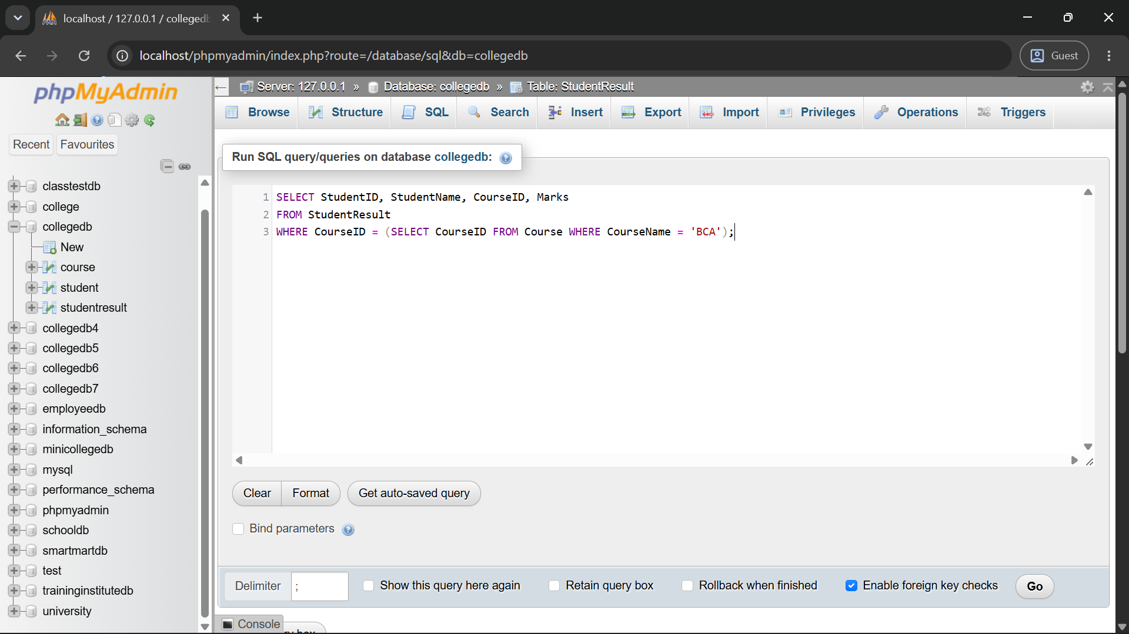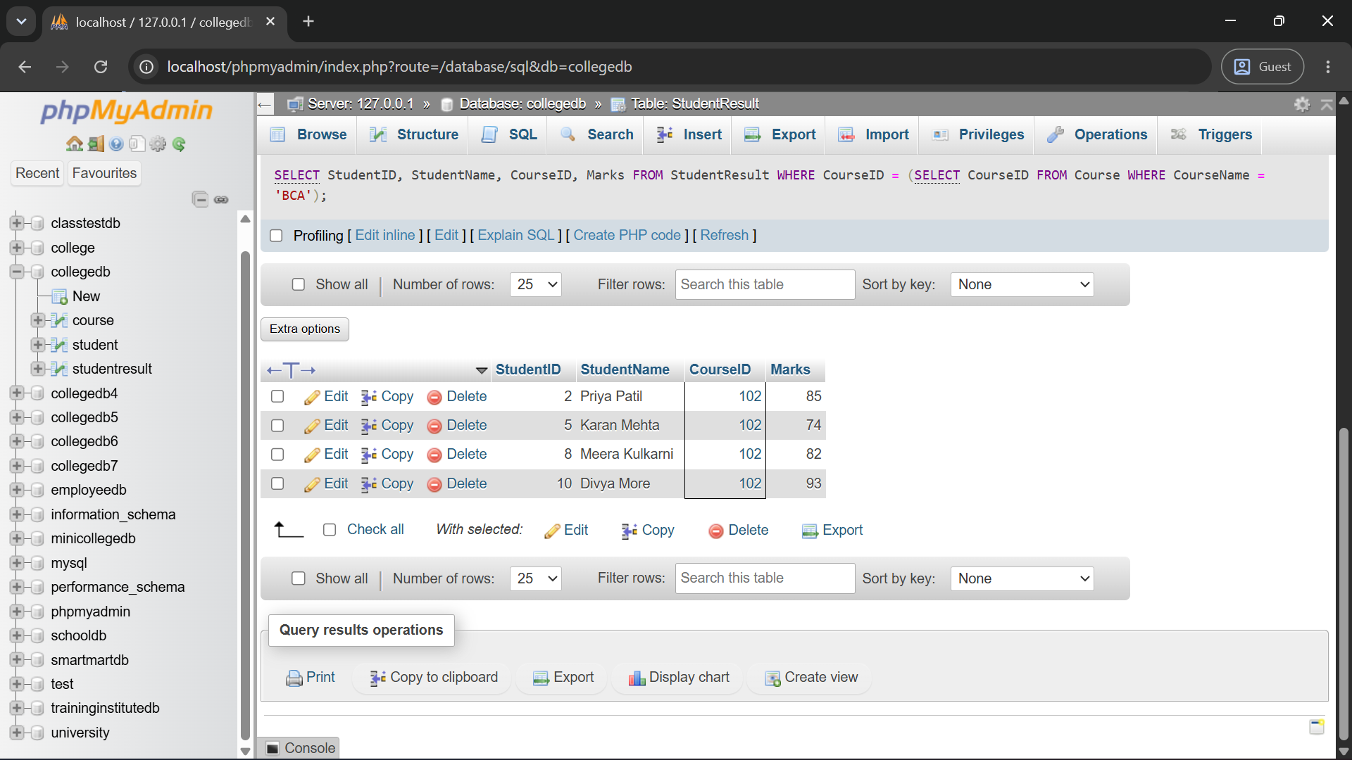

Q4) Write a MySQL query to display each student with the overall average marks using a subquery in the SELECT clause.
The output should contain:
Column
StudentName
Marks
AverageMarks
Query:
SELECT StudentName, Marks,
(SELECT AVG(Marks) FROM StudentResult) AS AverageMarks
FROM StudentResult;
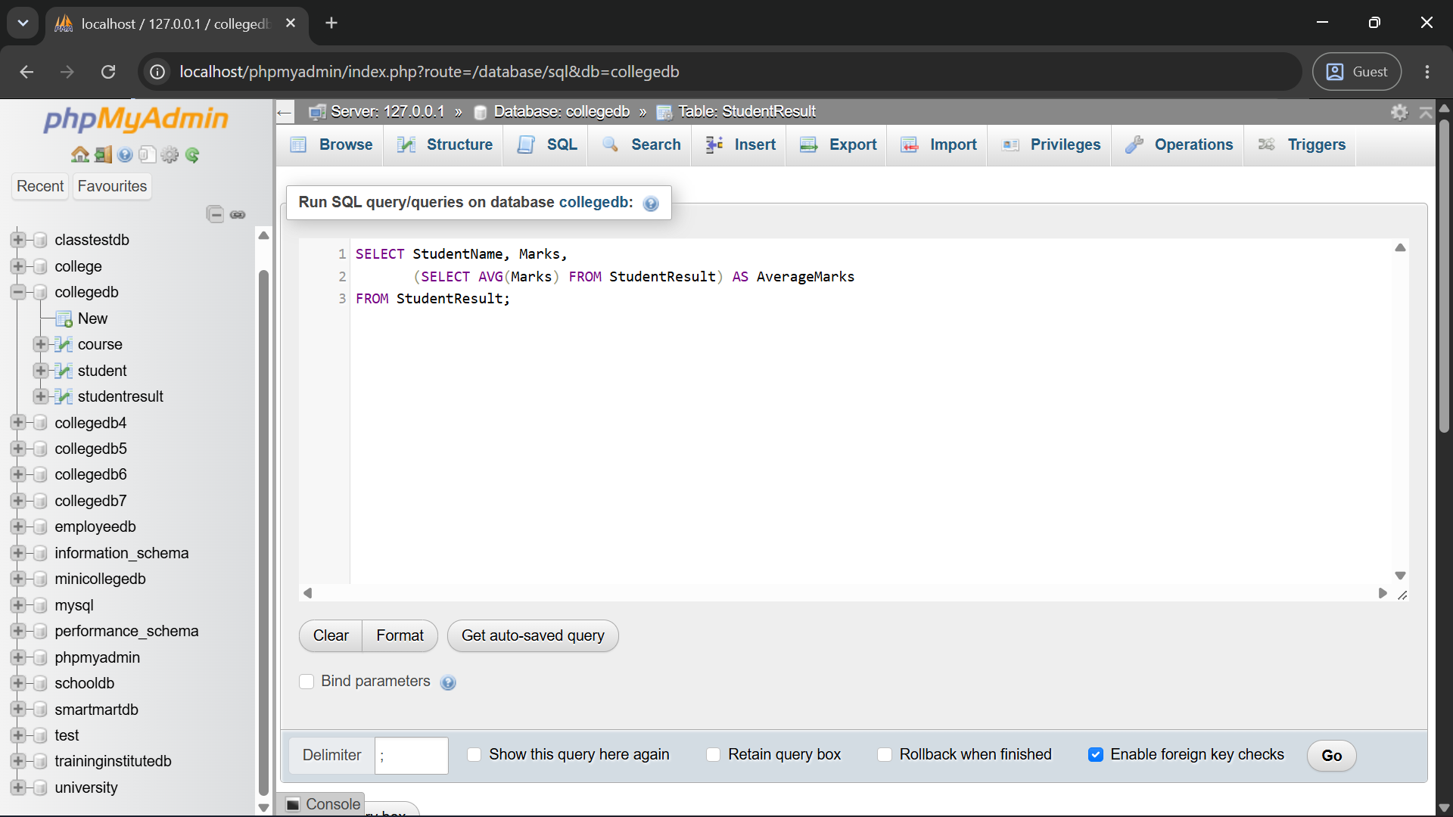
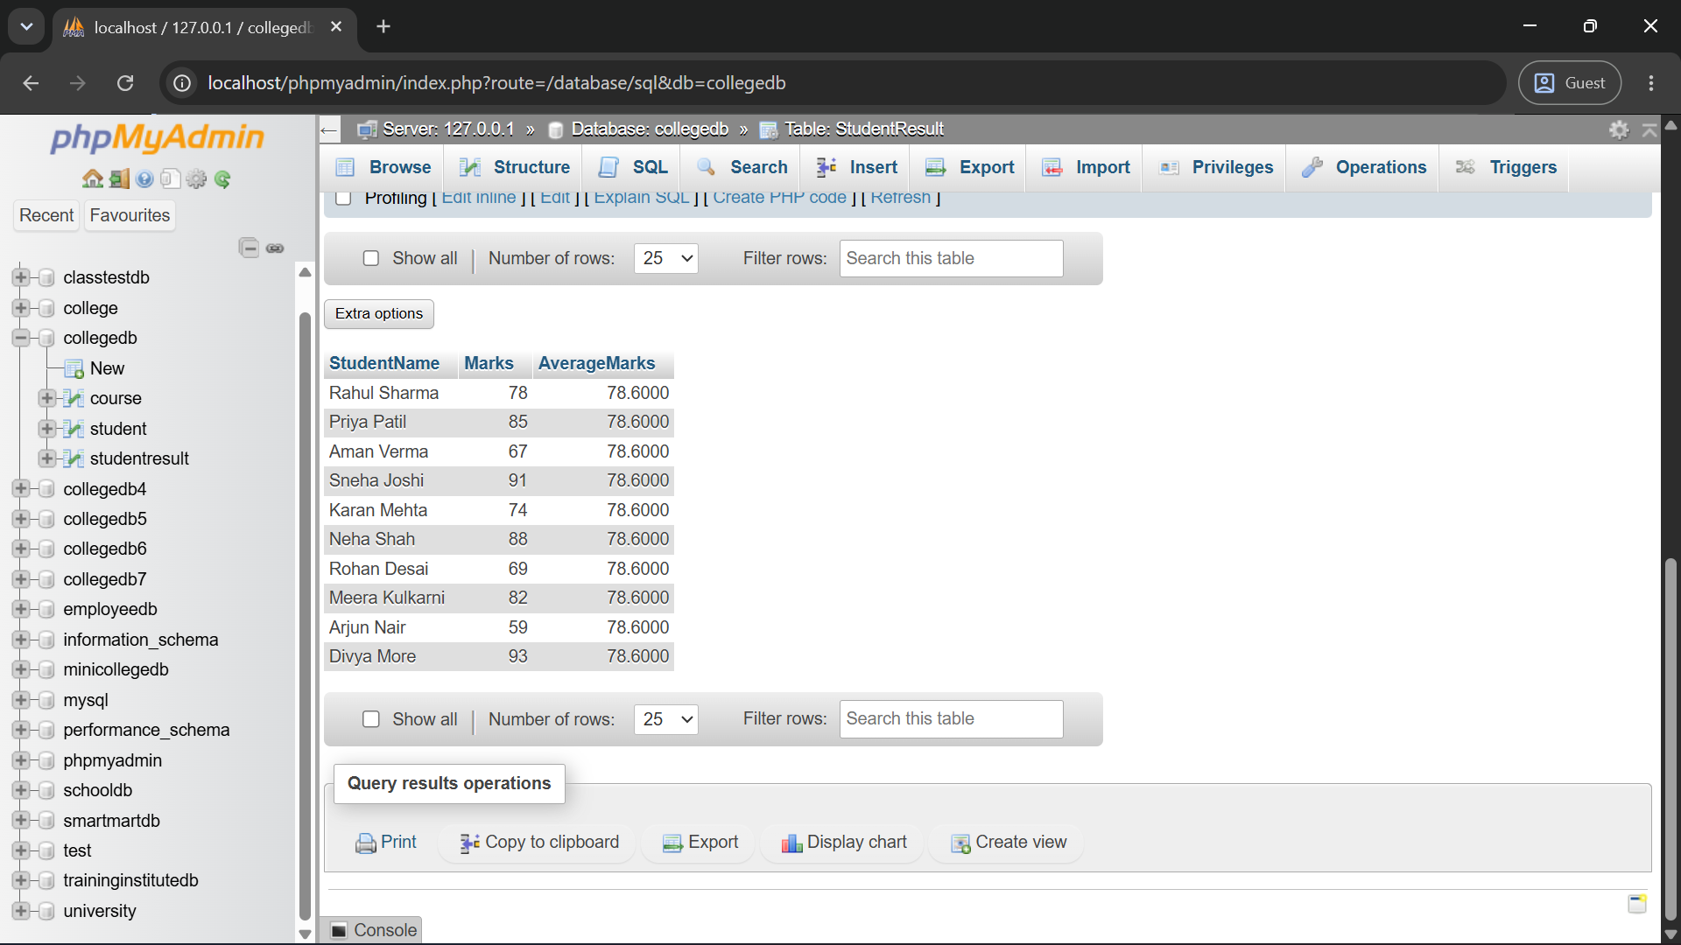
Q5) Write a MySQL query using a correlated subquery to display students who scored more than their own course average.
The output should contain:
Column
StudentID
StudentName
CourseID
Marks
Query:
SELECT StudentID, StudentName, CourseID, Marks
FROM StudentResult S1
WHERE Marks > (
SELECT AVG(Marks)
FROM StudentResult S2
WHERE S2.CourseID = S1.CourseID
);
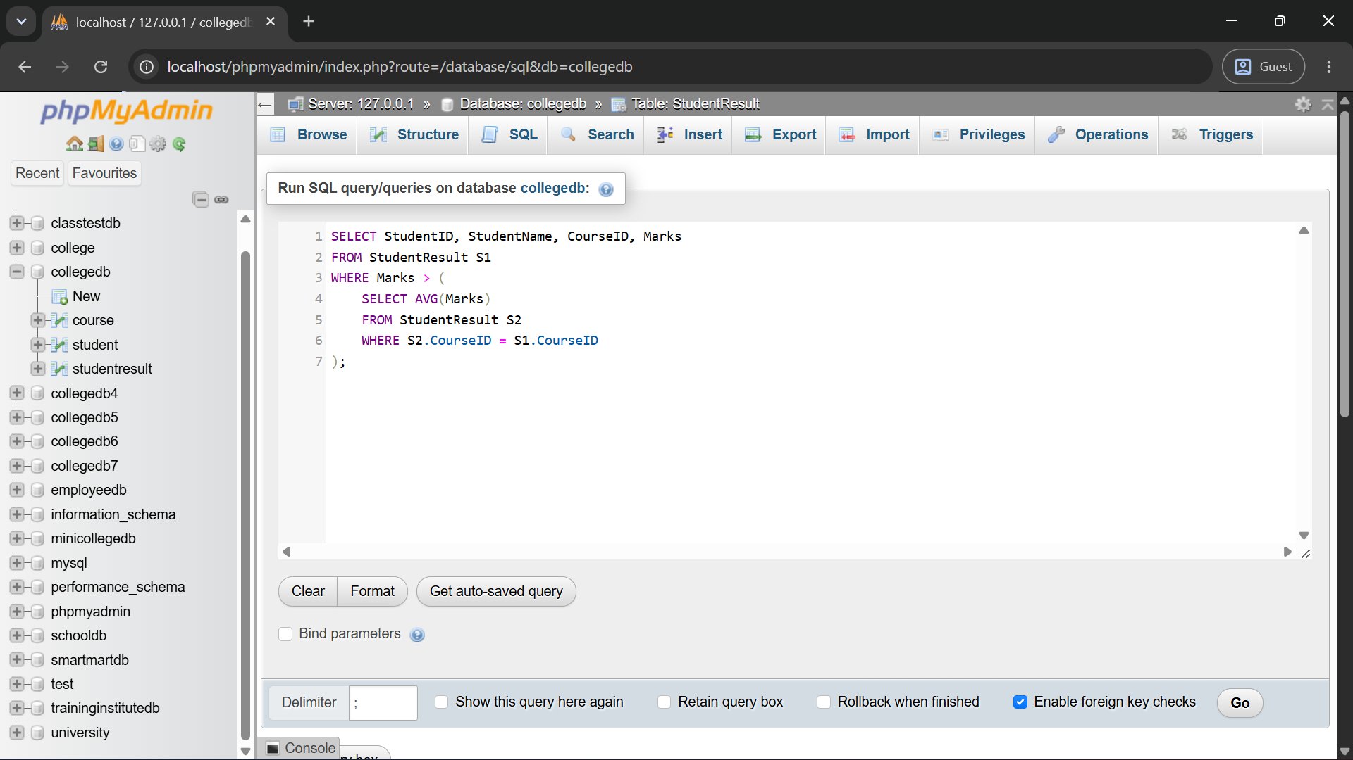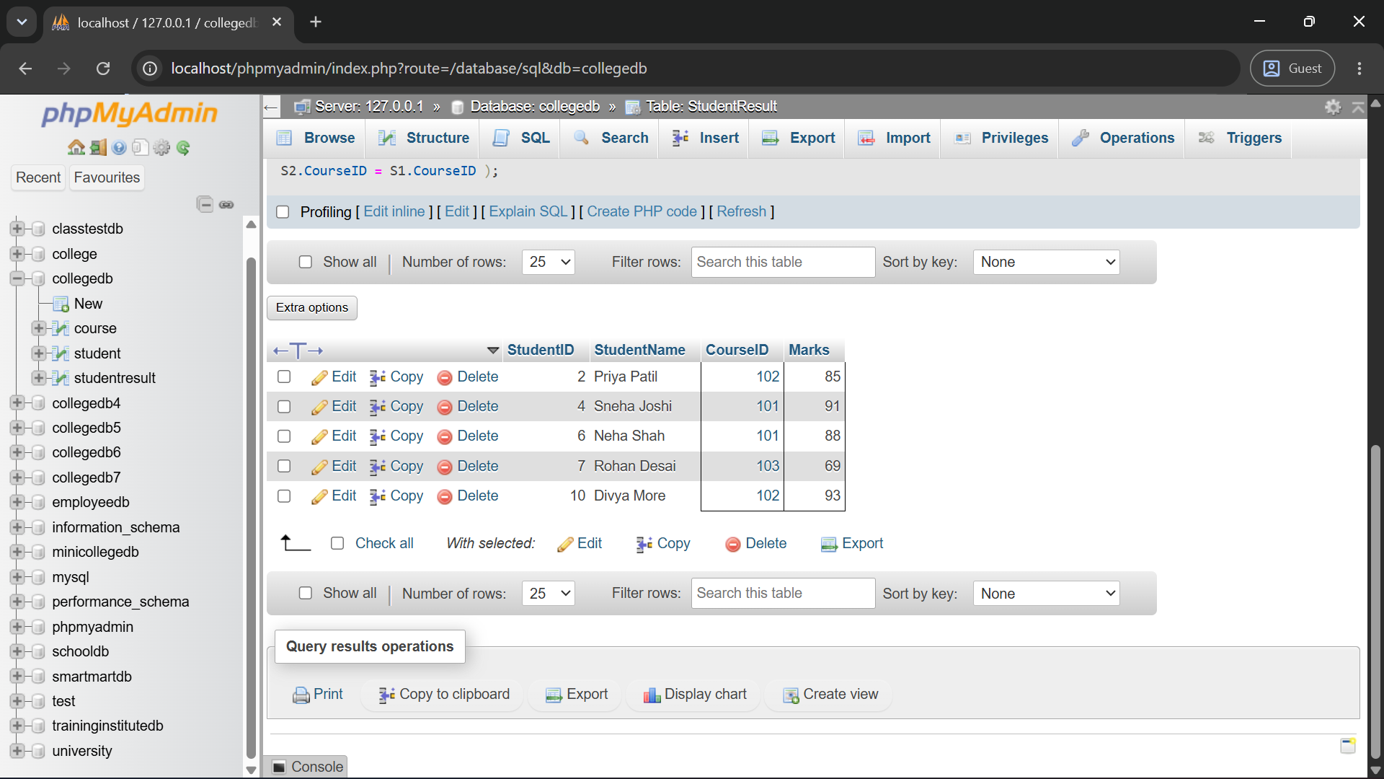

Q6) Write MySQL queries to display courses having students and courses having no students.
Use:
Operator
EXISTS
NOT EXISTS
Query:
SELECT CourseID, CourseName
FROM Course C
WHERE EXISTS (
SELECT 1 FROM StudentResult S WHERE S.CourseID = C.CourseID
);
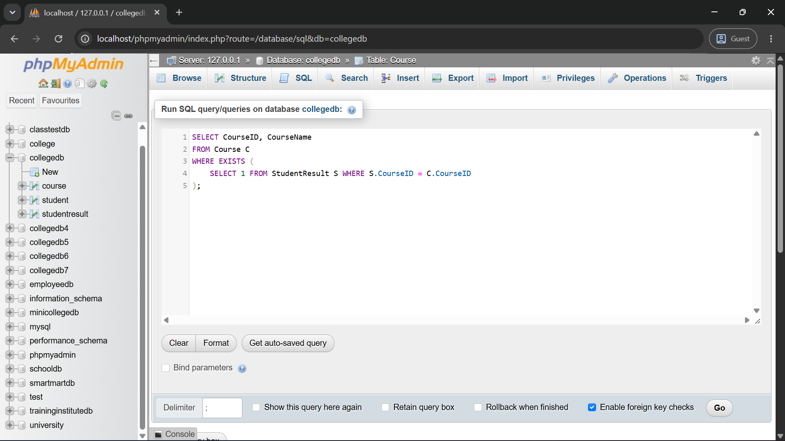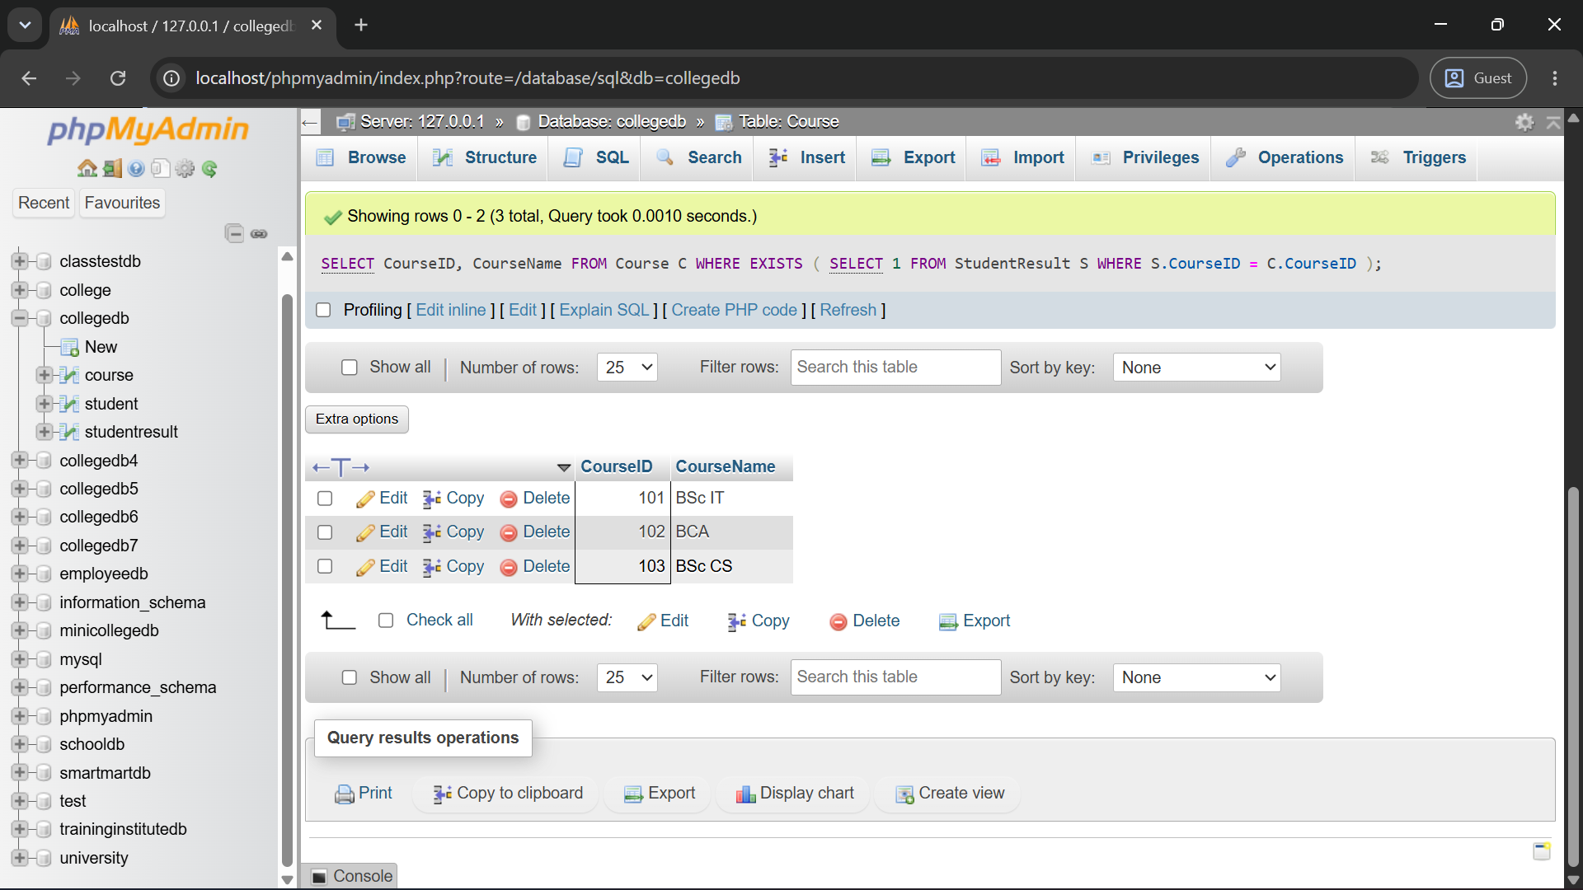
SELECT CourseID, CourseName
FROM Course C
WHERE NOT EXISTS (
SELECT 1 FROM StudentResult S WHERE S.CourseID = C.CourseID
); 